## Part 3: Implementation of the Case Studies

Please describe how each of the clinical case studies was implemented.

For each of the case studies, please use the format outlined below when reporting the implementation.

*This case is modeled according to the new version of the system that is not fully implemented yet, thus there are functionalities mentioned that were not present in the old version of the system.

### Input (1 page):

* Show the encoded CIGs required to solve the case in your approach formalism

Venous thromboembolism PROforma CIG modeling:

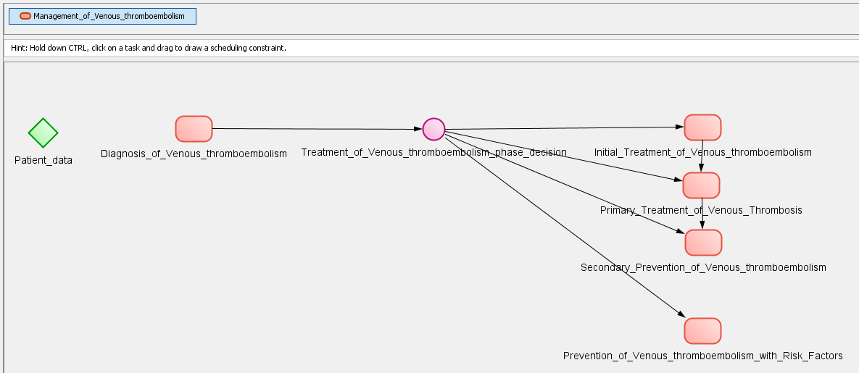

(a)

Addresses metaproperty: Verb: manage, Noun phrase object: Venous Thromboembolism N0000181252 NDF-RT

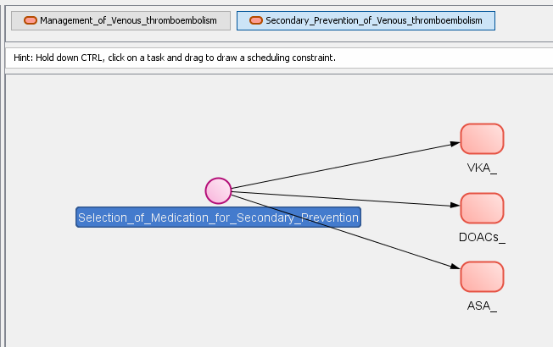

(b)

Addresses metaproperty: Verb: treat, Noun phrase object: Venous Thromboembolism N0000181252 NDF-RT

Figure 3-1. Venous thromboembolism PROforma CIG hierarchy tree. (a) shows the high-level plan of Management of Venous thromboembolism and its metaproperties. (b) shows the plan for secondary prevention.

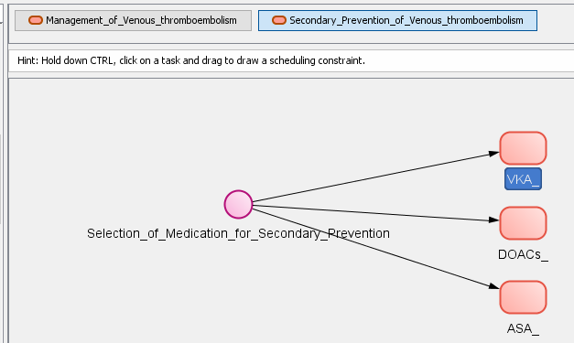

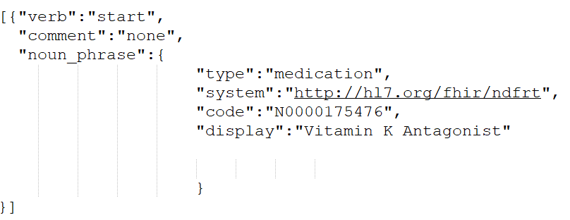

(a)

(b)

Decision arguments for Vitamin K Antagonists (Warfarin):

Warfarin decreases risk of recurrent VTE++

Warfarin is the preferred therapy due to dosage adjustment ability++

Warfarin is preferred by patients that have cost considerations++

Warfarin is recommended over DOACs for patients with Chronic Kidney Disease++

Warfarin is recommended for patients that were taking it previously without adverse effects during primary treatment++

Decision arguments against Vitamin K Antagonists (Warfarin):

If there is an allergy or intolerance to Warfarin, then it cannot be prescribed--

Warfarin is not recommended for patients with increased risk of bleeding--

Warfarin is not recommended for patients that are not able to come in frequently for INR monitoring--

Figure 3-2. (a) shows the “Addresses” metaproperty of the Vitamin K Antagonists plan. (b) shows the arguments behind the decision for selection of medication for secondary prevention of venous thromboembolism. For this particular patient, the argument for chronic kidney disease is irrelevant but all other positive arguments are relevant. The patient needs indefinite secondary prevention medication and warfarin can provide a better protection against recurrence of the condition. Additionally, warfarin allows fir dosage adjustment, costs less and the patient has been taking it for a while with no adverse effects. The negative arguments also play in favor of warfarin because the patient does not mind coming in for INR monitoring and she does not have an allergy or intolerance. When the choice for secondary prevention was made, the patient was not at risk of bleeding.

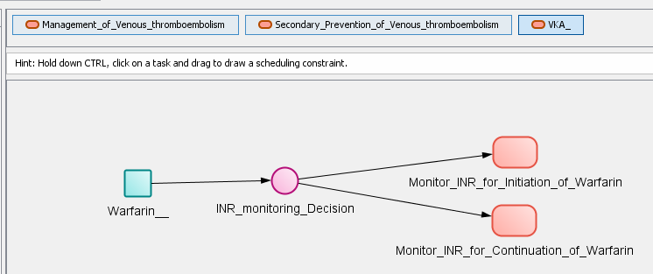

(a)

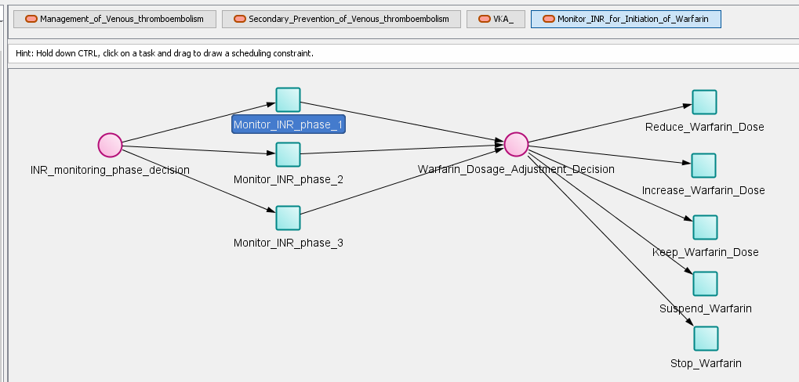

(b)

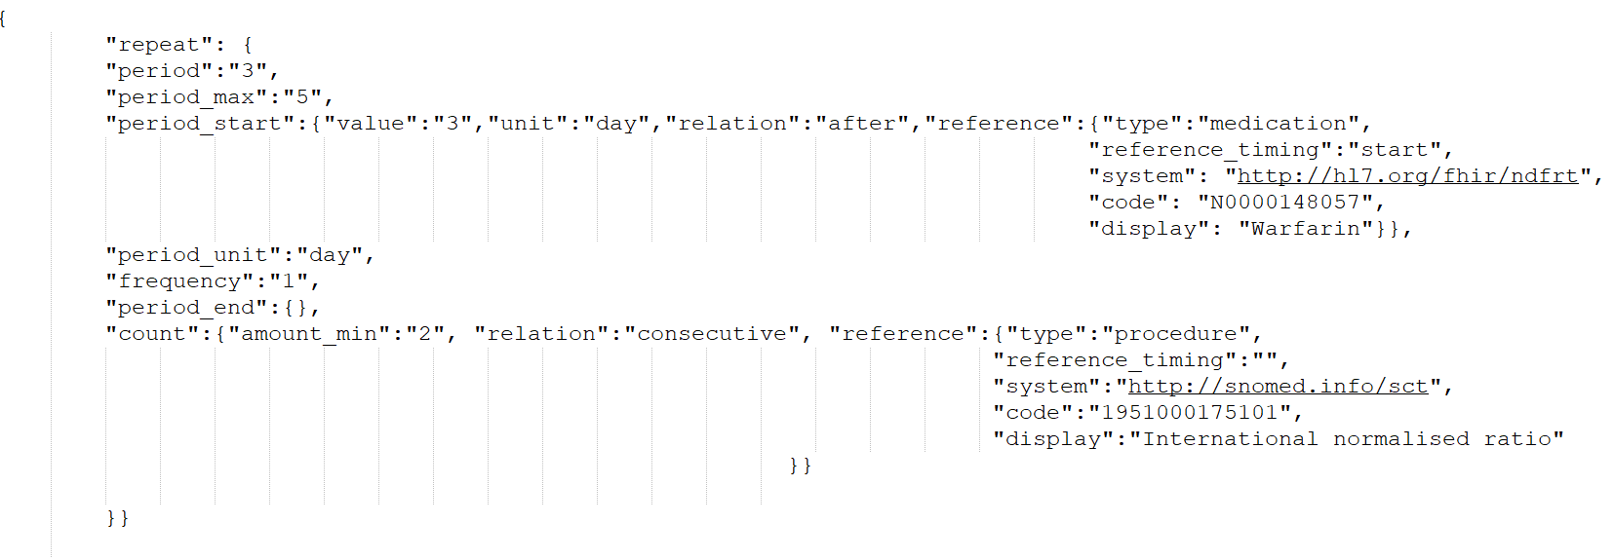

(c)

Figure 3-3. (a) shows the plan for Vitamin K Antagonists. Inside the plan there is a recommendation to start warfarin if it has not been started before. Then, according to when the warfarin was started and what phases of monitoring were completed in the guideline, the decision guides us to the plan for monitoring INR for initiation of warfarin or to the plan of monitoring INR for continuation of warfarin. (b) Inside the plan for monitoring for initiation of warfarin, there are three phases for monitoring. First – starting 3 days after the warfarin was initiated, every 3-5 days, until 2 consecutive INR tests within range. Phase 2 recommends monitoring once a week until 2 consecutive INR tests within range and phase 3 – once every 2 weeks until 2 consecutive tests within range. After all the phases in the plan are completed, we move to the continuation monitoring plan. (c) shows the “occurrenceTiming” of the service request for monitoring INR in the first phase. The range of INR is in the “Target” metaproperty of the parent goal plan (Same as in Figure 3-6.c).

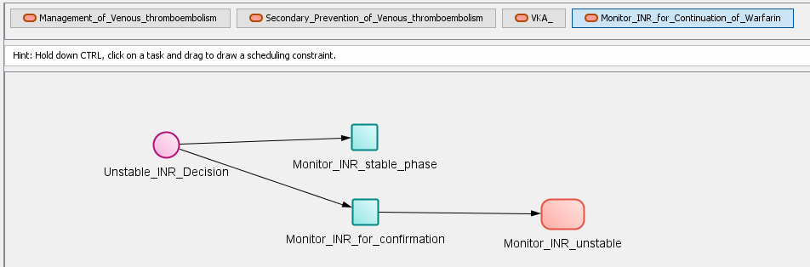

(a)

(b)

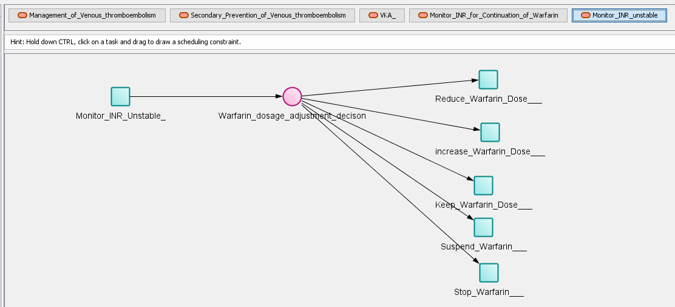

Figure 3-4. (a) shows the monitoring plan for patients that take warfarin continuously for secondary prevention of venous thromboembolism. The monitoring of INR during the stable phase is done every 4-6 weeks. If the INR gets out of range, another measurement is taken after 1 week to ensure that the problem persists. If the second measurement is out of range as well, we go into the plan for monitoring unstable INR. There are two different monitoring recommendations for high INR measurements and low INR measurements. For high measurements the recommendation is to monitor INR every 12-24 hours and according to those measurements we increase, decrease or keep the warfarin dose. We can also suspend or stop warfarin if needed. When INR goes back into range, we go back to the regular monitoring plan

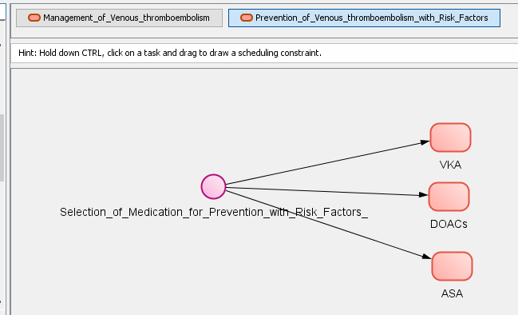

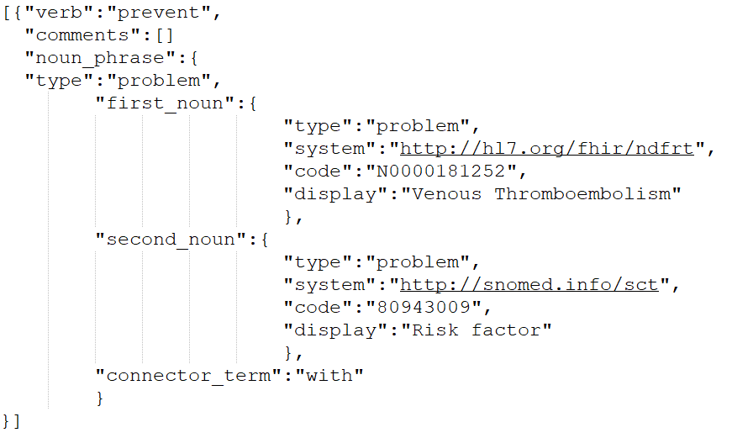

Figure 3-5. This is the plan for prevention of venous thromboembolism with risk factors present. The noun-phrase is a ‘complex noun-phrase’ and expresses that risk factors are present.

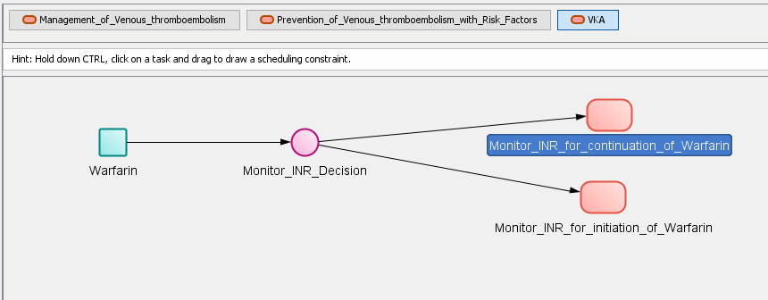

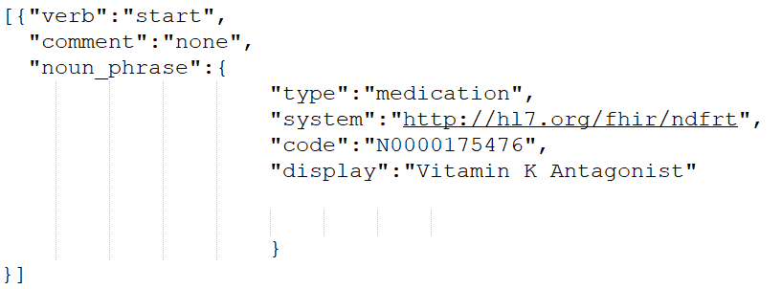

(a)

(b)

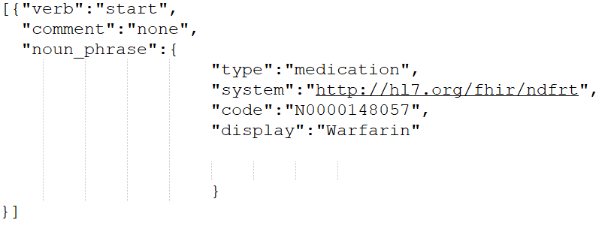

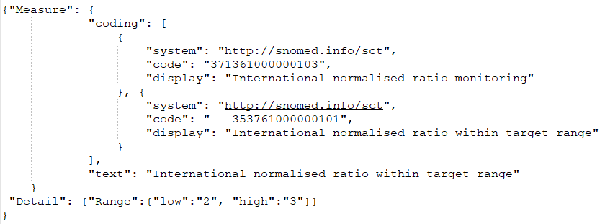

(c)

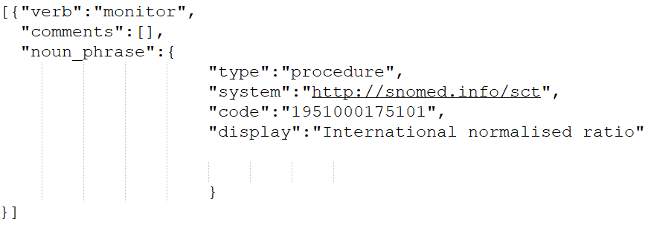

(d)

Figure 3-6. (a) Shows the “Addresses” metaproperty of the Vitamin K Antagonists goal plan that contains the recommendations for warfarin and Monitoring of INR. (b) shows the “Addresses” metaproperty of the warfarin recommendation. Even though the metaproperty has the verb “start”, the Controller will check when (if) warfarin was started and enter the information for the monitoring decision based on that. (c) shows the “Target” metaproperty that indicates which observation to monitor and what is the expected range. (d) shows the “Addresses” metaproperty of that same goal that recommends to monitor INR.

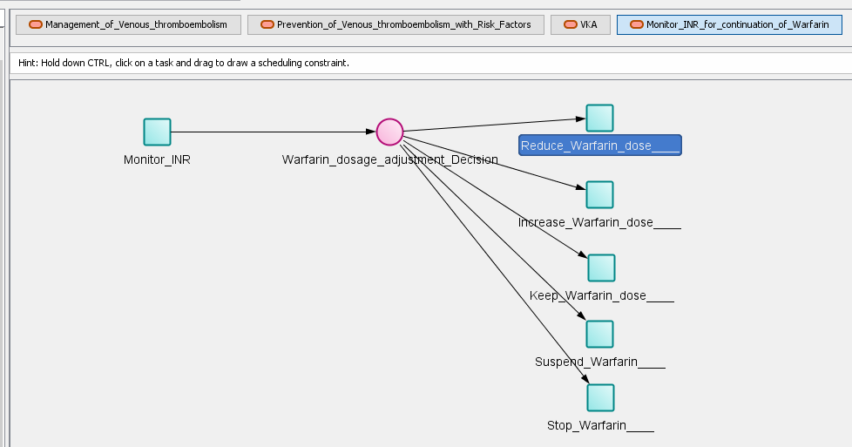

(a)

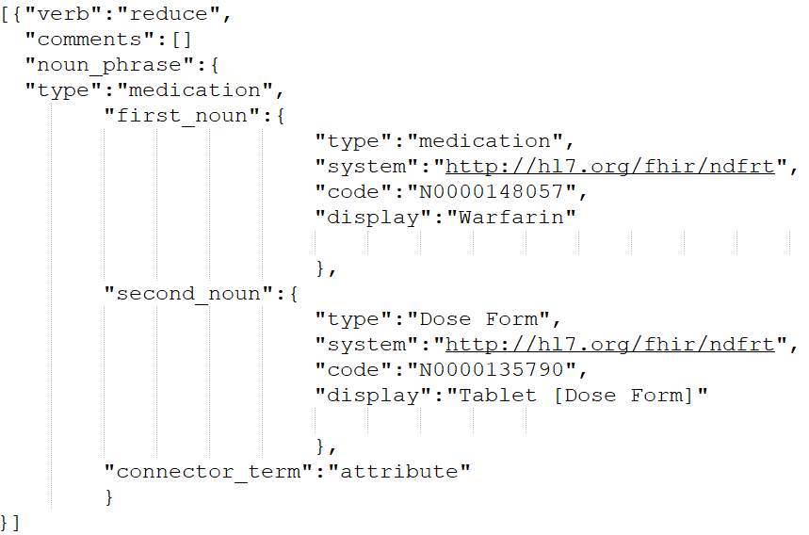

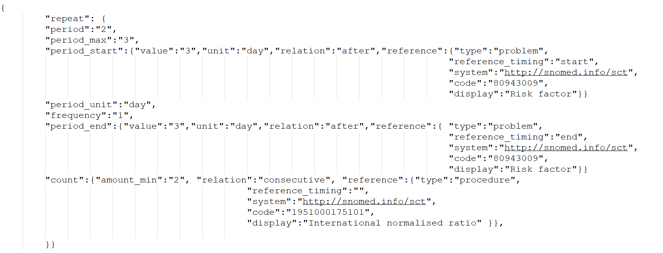

(b)

Figure 3-7. (a) Shows the “Addresses” metaproperty of the action-task that recommends to reduce warfarin dose in JSON format. The metaproperties of the task to reduce warfarin dose indicate that the attribute to be changed is the dose and the recommended change is to “decrease” the dose. (b) Shows the “occurrenceTiming” of a service request resource. This resource is akin to the “procedure request” resource in previous version of the HL7 and will be used as such here, though in FHIR it is more generic and has additional uses. The described timing recommends to start monitoring the INR 3 days after starting the new warfarin dose. The plan is repeating with the stopping condition that 3 days after the risk factors have been eliminated, there have been two observations of INR between values 2 and 3, which shows a stable INR measurement. The service request references the procedure mentioned in the “Addresses” of the parent plan. The Controller will look for observations according to that metaproperty and the “Target” of the parent plan goal that states that INR should be between 2 and 3.

Acute uncomplicated cystitis and UTI PROforma CIG modeling:

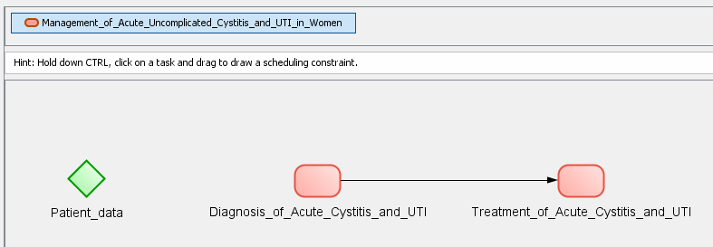

(a)

Addresses metaproperty: Verb: manage, Noun phrase object: Urinary Tract Infections N0000003081 NDF-RT

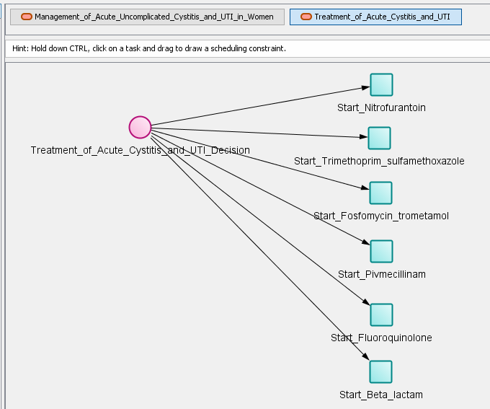

(b)

Addresses metaproperty: Verb: treat, Noun phrase object: Urinary Tract Infections N0000003081 NDF-RT

Figure 3-8. Urinary Tract Infections PROforma CIG hierarchy tree. (a) shows the high-level plan of Management of Urinary Tract Infections and its metaproperties. (b) shows the plan hierarchy as well the metaproperties of the plan of Treatment of Acute Cystitis and UTI.

The Goal Trees for this case are shown in Figure 3-10.

Example of a FHIR resource (for Case 3): Chronic Kidney Disease (CKD)

{

"resourceType": "**Condition**",

"id": "6541235",

"clinicalStatus": {

"coding": [ {

"system": "http://terminology.hl7.org/CodeSystem/condition-clinical",

"code": "active"

} ]

},

"verificationStatus": {

"coding": [ {

"system": "http://terminology.hl7.org/CodeSystem/condition-ver-status",

"code": "confirmed"

} ]

},

"category": [ {

"coding": [ {

"system": "http://snomed.info/sct",

"code": "282291009",

"display": "Diagnosis of"

} ]

} ],

"code": {

"coding": [ {

"system": "http://hl7.org/fhir/ndfrt",

"code": " N0000181252",

"display": "**Venous Thromboembolism** "

} ]

},

"subject": {

"reference": "Patient/150",

"display": "Margaret Mclane"

},

"onsetDateTime": "2016-09-23",

}

Figure 3-9 FHIR Condition of Venous Thromboembolism (that the patient exhibits)

* If applicable, show how adverse interactions (features A1-A7) were encoded a-priori

Not applicable

* If applicable, show/reference the encoding of additional domain knowledge

### Processing (1 page):

* If applicable, explain how relevant interactions were (automatically) identified (features A1-A7)

**A1 - Drug from a CPG has an effect on a comorbid condition (including ADE)**

A risk of bleeding is concluded by the Controller when checking for interactions and searching the system’s knowledge base for potential adverse effects, due to the patient taking warfarin and being diagnosed with an infection along with being prescribed antibiotics. Both the infection and the antibiotics potentiate the effects of warfarin and increase the risk of bleeding. The risk of bleeding is indicated as one of the possible risk factors in the venous thromboembolism guideline.

**A2 - Two or more drugs from different CPGs may interact**

In case 3, warfarin is found to have an interaction with the recommended antibiotic Trimethoprim – sulfamethoxazole. When checking for consistency, the algorithm searches the RxNav interactions database and finds that the two drugs have a number of interactions: (a)The metabolism of warfarin can be decreased when combined with Trimethoprim, (b) The serum concentration of warfarin can be increased when it is combined with Sulfamethoxazole. This helps the Controller conclude that there may be a risk of bleeding since antibiotics can increase the anticoagulation effect of warfarin due to its altered metabolism and concentration.

**A6 – Temporal relationships between different CPGs**

The monitoring on the INR for treatment of Venous Thromboembolism with risk factors is modeled to stop after 2 consecutive measurements of INR between 2 and 3 have been observed, after the risk factors’ (e.g., antibiotics) presence has ended. Since the risk factors come from a different guideline (UTI), this requires a temporal relationship between the two guidelines.

**A9 - Adjust drug dosage**

While the new recommendation to start warfarin with reduced dose does not specify the new warfarin dose, the intent is to indicate that a reduction is needed and the amount of dose reduction may be stated in the comments of the recommendation metaproperty.

**A10 - Monitor the effect of a drug**

The ‘Monitor INR’ recommendation in the venous thromboembolism guideline helps monitor the effects of the warfarin treatment. For case 3, the sub guideline that is modeled for taking into account present risk factors is relevant, additionally, INR monitoring is relevant all throughout the venous thromboembolism guideline where warfarin treatment is prescribed.

**A15 - Patient preferences and/or patient burden**

According to the case description, warfarin is preferred both in the guideline and by the patient when she first started taking it. The guideline will receive data items from the Knowledge base that indicate whether the patient has cost considerations (warfarin has a lower cost) and whether the patient is concerned about the frequency of visits (Patient will have to do frequent INR monitoring if warfarin is prescribed). The Trimethoprim-sulfamethoxazole antibiotic is recommended because previous treatment was successful.

**A16 - Optimization of clinical resources – we don't support it**

**A17 - Explanation of the mitigation strategy(ies)**

After the different options are created, the Controller creates explanations for each individual goal in each option and a higher-level explanation for each option. The explanations for the individual goals are either retrieved from the guideline or can be auto-generated by the Controller according to pre-defined patterns that take into account the verb and lifecycle Status attribute of the goal (steps 15-27 in Kogan et al. [1] Figure 12 (Pattern F) and in Kogan et al. [1] Table 2).

**A18 - Alternative mitigation strategies for a single interaction –** The Controller produces multiple option-sets by applying different mitigation strategies to an interaction. When mitigating the interaction [Start Trimethoprim-sulfamethoxazole, Start Warfarin], the Controller will produce both options that keep warfarin with the original dose and reduce the warfarin dose. Additionally, the Controller will recommend to monitor INR more frequently. While in the guideline it is preferred to change the warfarin dose after IRN monitoring indicates to do so, it is also stated that with expert advice the dose can be changed pre-emptively. Thus, both options are relevant and will be displayed to the user.

* Explain which parts of the processing are generic and which need to be hardwired for the case[1]

Processing is not hard-wired.

Replacement drugs are represented in the CIGs.

### Output (1 page):

* Show and explain how the result of the processing is represented

The results of the processing have intermediate representation as alternative Goal trees (See Figure 3-11).

**Goal Forest**

**1 Management of Venous thromboembolism**

**1.3 Secondary Prevention of Venous thromboembolism**

**1.3.1 VKA**

**1.3.1.1 Warfarin**

**1.3.1.3 Monitor INR for continuation of Warfarin**

**1.3.1.3.1 Monitor INR stable phase**

**2 Management of Acute Uncomplicated Cystitis and UTI in Women**

**2.2 Treatment of Acute Cystitis and UTI**

**2.2.1 Antimicrobial treatment of Cystitis and UTI**

**2.2.1.1 Start Trimethoprim sulfamethoxazole**

Figure 3-10. A schematic representation of the 2 goal trees for the 2 CIGs.

From these, the final output of the option-sets and explanations are derived and presented to users.

The method reports to the user all of the goals for the patient and non-conflicting option sets that meet the goals along with automatically-generated explanations generated from the CIG representation that includes quotes from the CPGs and automatically-generated explanations on the strategy of mitigation and how it has been applied for the case.

Each option-set includes a set of options from the different goal trees of the patient – the ones involved in mitigating the conflicting goals. An option-set is a subtree of the goal tree where the siblings, if any, represent a conjunction of sub-goals. The nodes in the full goal tree, or in the option-pathway are represented as a Goal FHIR object, that start in the root node, with children that are also Goal FHIR objects with children, all the way down to the leaf-node. Note that the property "Proposed action" – contains the future status of the goal as proposed by the Controller during mitigation.

Figure 2-6 provides a schematic representation of an option-set with one pathway for each CIG. Each pathway has multiple nodes from root to leaf. Each line below corresponds to a node in the pathway. The indentation reflects a child-parent relationship.

**Option-set 1 Replace secondary prevention plan with prevention with risk factors plan; Reduce or keep warfarin dose and monitor INR for continuation of warfarin with risk factors present.**

**1 Management of Venous thromboembolism**

**1.3 Secondary Prevention of Venous thromboembolism**

**Proposed_action: replace [action_object_1: 1.3 (Secondary Prevention of Venous thromboembolism)**

**1.3.1 VKA 1.3.1.1 Warfarin**

**1.3.1.3 Monitor INR for continuation of Warfarin**

**1.3.1.3.1 Monitor INR stable phase]**

**with**

**action_object_2: [1.4 (Prevention of Venous thromboembolism with Risk Factors)**

**1.4.1 VKA 1.4.1.1 Warfarin 1.4.1.3 Monitor INR for continuation of Warfarin**

**1.4.1.3.1 Monitor INR with Risk Factors**

**{1.4.1.3.2 Reduce Warfarin dose**

**or**

**1.4.1.3.3 Keep Warfarin dose}]**

**2 Management of Acute Uncomplicated Cystitis and UTI in Women**

**2.2 Treatment of Acute Cystitis and UTI**

**2.2.1 Antimicrobial treatment of Cystitis and UTI**

**2.2.1.1 Start Trimethoprim sulfamethoxazole**

Figure 3-11. A schematic representation of the json for Option set 1.

Note that as compared to Figure 3-10, there is also a proposed_action part. The proposed action may be to accept, reject, keep, replace, suspend, activate, cancel and complete a goal/action.

After the user selects his preferred option set, the goal tree is updated as is the patient's EHR.

* Show and explain what user interactions were involved in the use case
  + User adding a new problem - UTI (which triggers the CDS)
  + System providing explanations to the user – See below.
  + User selecting one of the recommended option sets (Option 3 in Figure 3-12). This results in the patient’s EHR being updated

Figure 3-12 shows the options-sets for Case3. Figures 3-13 and 3-14 show explanations about one goal from one option-set and about an entire option-set, respectively.

To be completed

Figure 3-12. the option sets for Case 3

There are individual explanations for each recommendation which the user can see when they click on the recommendation for one goal of one of the decision options:

To be completed

Figure 3-13. An explanation for the recommendation to reduce the regular Warfarin dose

As well as explanations for the entire option set:

To be completed

Figure 3-14. An explanation for the entire option-set. The explanation is auto-generated.

* Explain any additional considerations.

Not applicable

1. There are two aspects: (**1**) processing algorithm: in a generic approach, only models change across case studies, while a hardwired approach requires tweaking the algorithm for each case study; (**2**) domain knowledge: a mitigation strategy can be generic or hardwired: e.g., deriving which drug should replace another drug can come from a knowledge base or be hard-wired for each case study (e.g., based on guidelines). There can be degrees of generality as well, of course.